**Lab Exercise # 8**

**Name:** Josiah Joed G. Getes

**Course & Year:** BSCS – 1

**Objectives:** To read data on a sequential file and place it on a structure.

To compute the standard deviation of the record and write the result on another sequential file.

**CODE:**

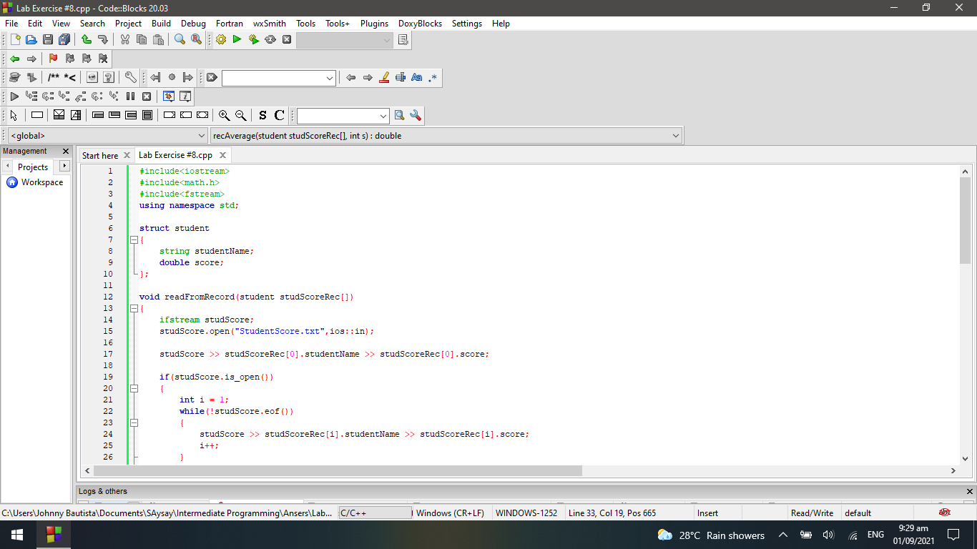

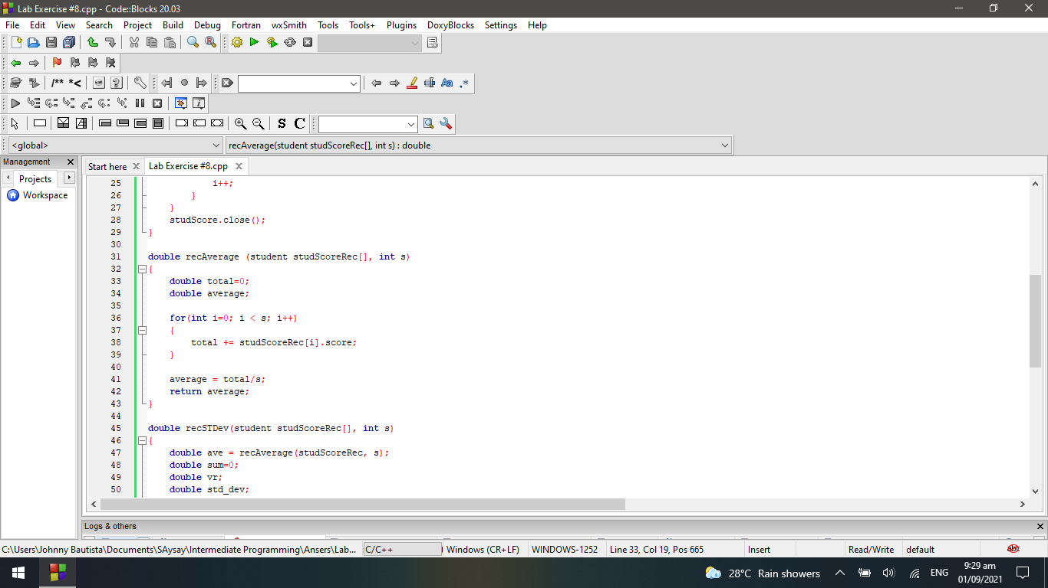

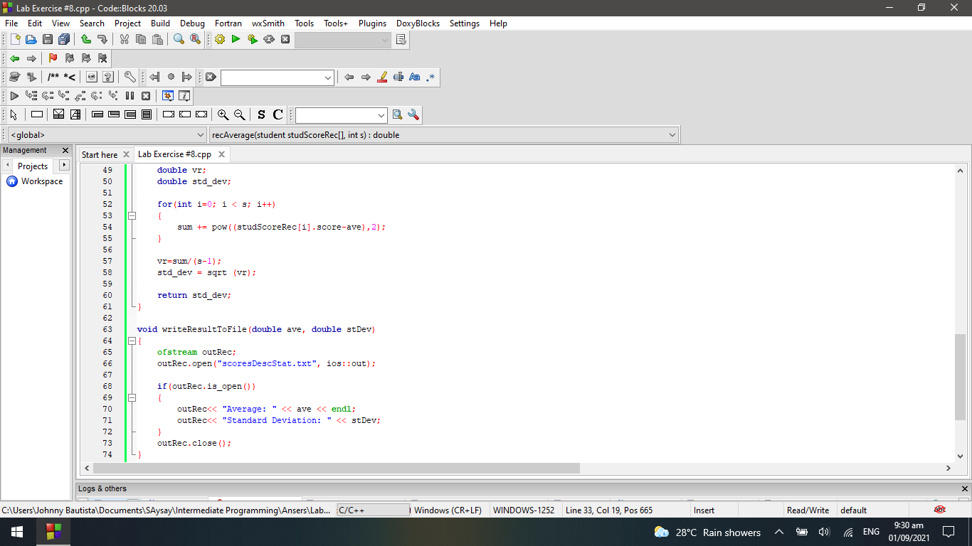

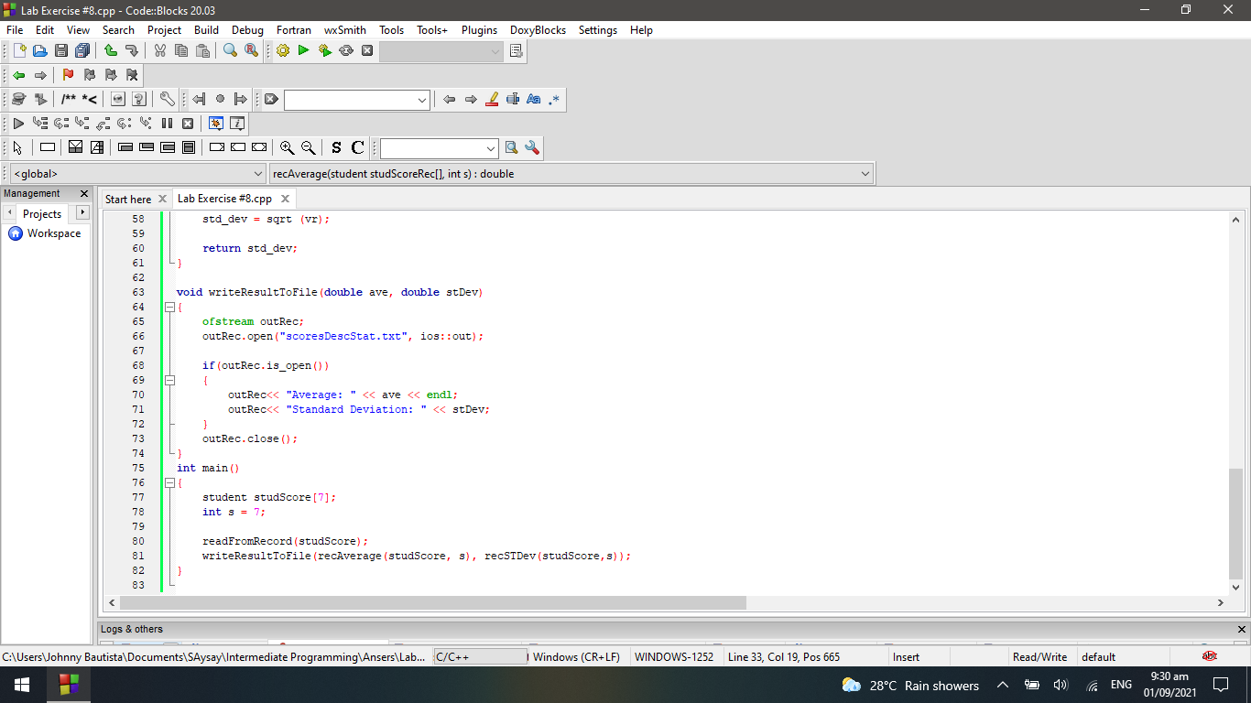

**TEXTFILES:**

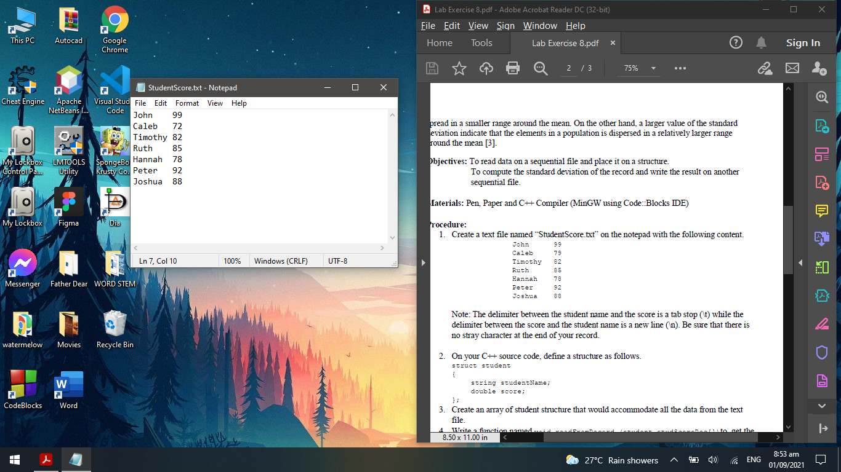

**RESULT:**

